EXPT NO:3 | Designing Multivariate Patterns
DATE: 12.01.2026 | Designing Multivariate Patterns

PRE-LAB QUESTIONS (PROVIDE BRIEF ANSWERS TO THE FOLLOWING QUESTIONS)

1. Why is multivariate analysis essential in real-world AI problems?
Multivariate analysis is essential because real-world AI problems involve multiple interacting variables rather than a single factor. AI systems such as fraud detection, healthcare diagnosis, and recommendation engines must analyze many features simultaneously to uncover patterns, relationships, and dependencies. This improves prediction accuracy, decision-making, and model reliability.
2. What challenges arise when visualizing high-dimensional data?
Visualizing high-dimensional data presents several challenges:
- Visual clutter, making patterns hard to interpret
- Overlapping data points, which hide meaningful relationships
- Loss of information when reducing dimensions
- Cognitive overload for users
3. How does correlation analysis support feature selection?
Correlation analysis identifies the strength and direction of relationships between variables. In feature selection:
- Highly correlated features may be redundant
- Removing redundant features reduces overfitting
- It improves model efficiency and interpretability
4. What are ethical concerns in healthcare data visualization?
Ethical concerns include:
- Patient privacy breaches
- Misleading visual representations that can affect clinical decisions
- Bias amplification due to incomplete or skewed data
5.Give examples of multivariate data in AI systems
Examples of multivariate data include:
- Healthcare AI: Age, blood pressure, glucose level, cholesterol, diagnosis
- Fraud detection: Transaction amount, location, time, device type
- Recommendation systems: User preferences, ratings, browsing history

IN-LAB EXERCISE:
OBJECTIVE:
To discover relationships among multiple variables using multivariate visualization.
SCENARIO:
A hospital analytics team studies patient health records to identify relationships between age, BMI, glucose levels, and blood pressure for early disease prediction.
IN-LAB TASKS (Using R Language)

1.Generate scatter plot matrix

Code:
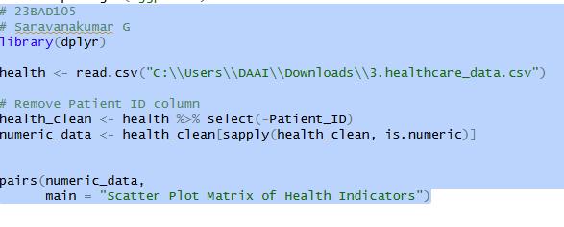
Output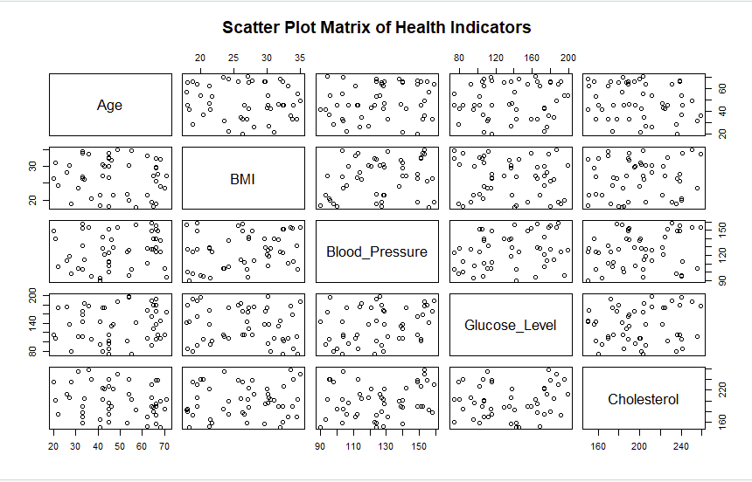

2. Apply color encoding for age groups

Code:

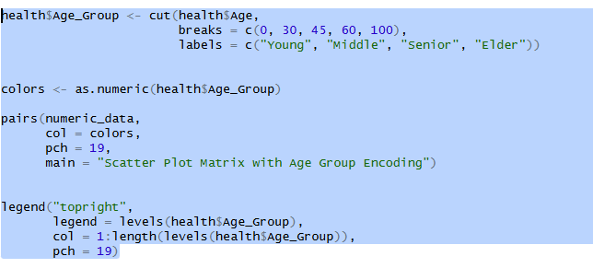

Output:
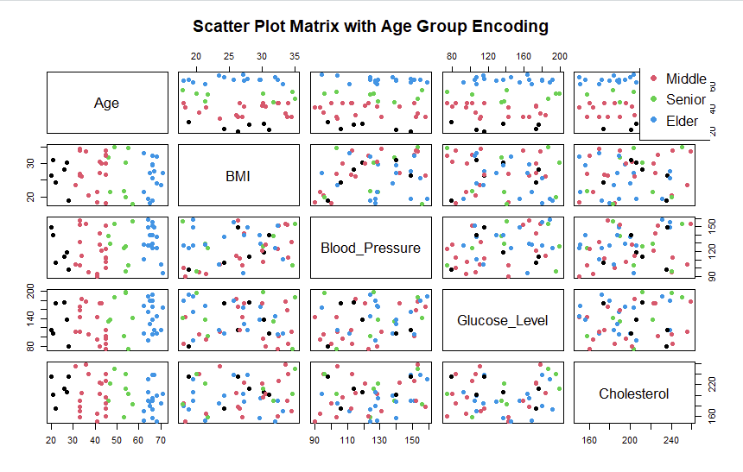
3.Identify correlated health indicators

Code:
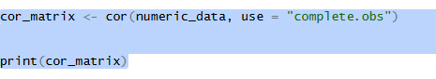

Output:

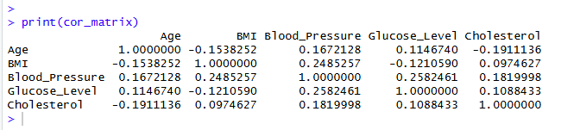

POST-LAB QUESTIONS (PROVIDE BRIEF ANSWERS TO THE FOLLOWING QUESTIONS)

1. Which health parameters show strong correlation?
Common health parameters that often show strong correlation include:
- Blood glucose and HbA1c (diabetes monitoring)
- Body Mass Index (BMI) and blood pressure
- Cholesterol levels and cardiovascular risk
- Heart rate and physical activity level
- Age and prevalence of chronic diseases
These correlations help identify risk factors and disease progression.

2. Why does correlation not imply causation in medical data?
Correlation does not imply causation because:
- Two variables may be influenced by a third hidden factor
- The relationship may be coincidental
- Data may be affected by bias or confounding variables
For example, ice cream sales and heat stroke cases correlate due to temperature, not causation.

3. How can these patterns assist predictive healthcare AI?
These patterns assist predictive healthcare AI by:
- Improving early disease detection
- Supporting risk stratification
- Enhancing feature selection for models
- Enabling personalized treatment recommendations
AI systems use correlated parameters to predict outcomes more accurately.

4. What visualization limitations exist for high-dimensional data?
Limitations include:
- Overlapping data points
- Visual clutter
- Difficulty in interpreting many variables at once
- Limited display dimensions (2D/3D screens)
- Increased cognitive load
These issues make insights harder to extract without advanced techniques.

5. How can dimensionality reduction improve visualization?
Dimensionality reduction techniques (PCA, t-SNE, UMAP):
- Reduce data into lower-dimensional representations
- Preserve important patterns and variance
- Improve clarity and interpretability
- Enable effective 2D or 3D visualization

ASSESSMENT
Description | Max Marks | Marks Awarded
Pre Lab Exercise | 5
In Lab Exercise | 10
Post Lab Exercise | 5
Viva | 10
Total | 30
Faculty Signature

